**2020 Scientific Journal Management Editorial Guide**

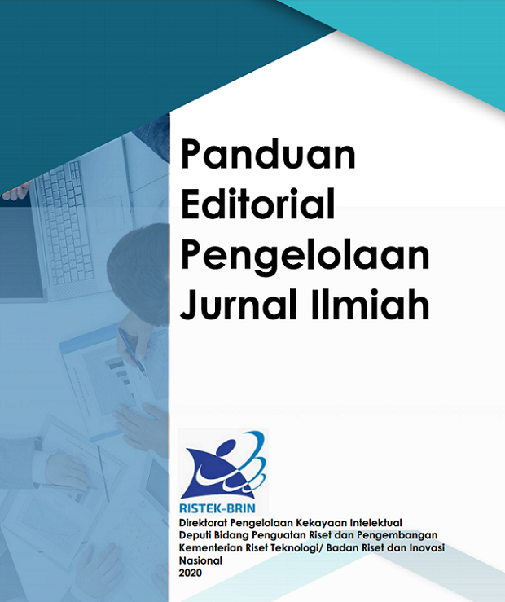By: **Cindra Zakaria**. December 23, 2020 10:59:23

***Panduan Editorial Pengelolaan Jurnal Ilmiah*: Scientific Journal Management Editorial Guidelines**

***Direktorat Pengelolaan Kekayaan Intelektual*: Directorate of Intellectual Property Management**

***Deputi Bidang Penguatan Riset dan Pengembangan*: Deputy for Research and Development Strengthening**

***Kementerian Riset dan Teknologi/Badan Riset dan Inovasi Nasional*: Ministry of Research and Technology/National Research and Innovation Agency**

**2020**